Alex Iacob

Prof. Kinsman

CSCI 431

August 28, 2022

**HW 00**

For starters, here is me standing next to the mental health awareness poster.

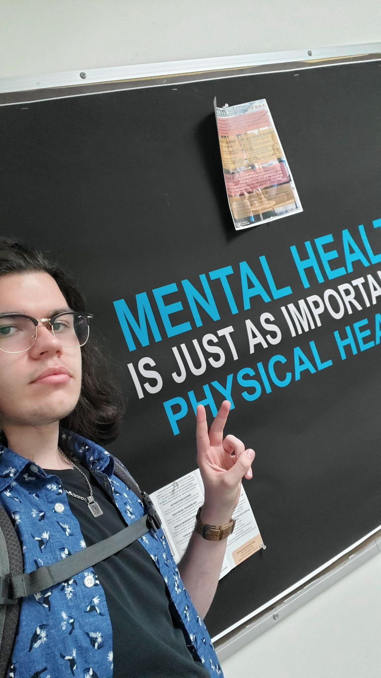

This is the basic photo that was used in the program.

(Question 4a)

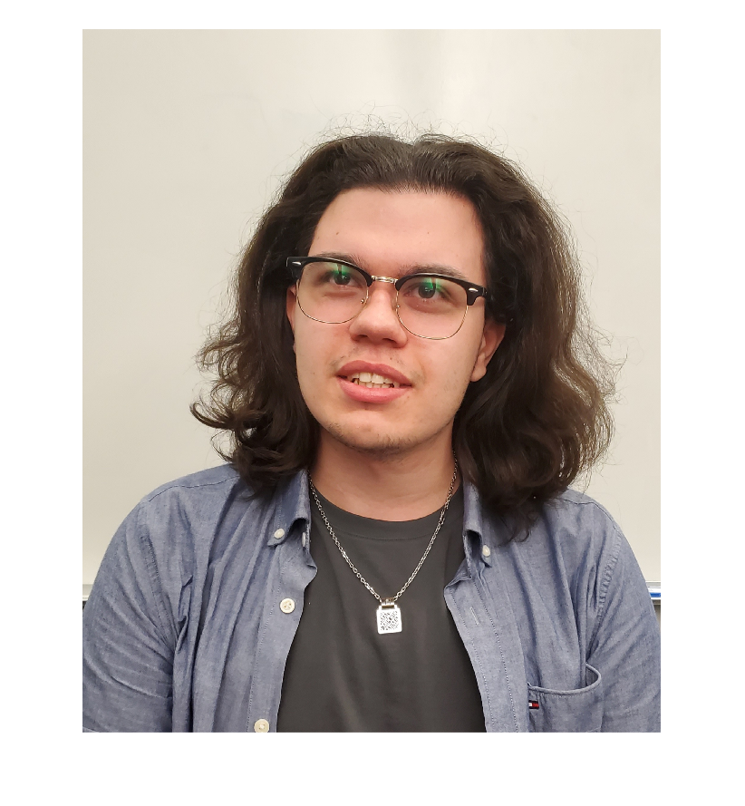

Grayscale image

(Question 4b)

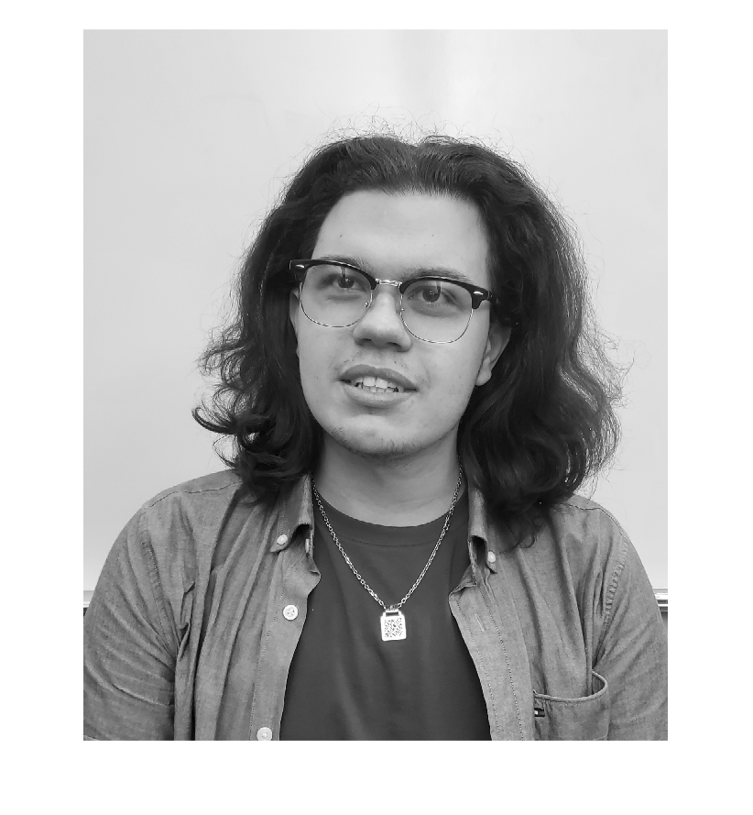

Shrunken Image

(Question 4c)

The maximum size of the image was 5742.

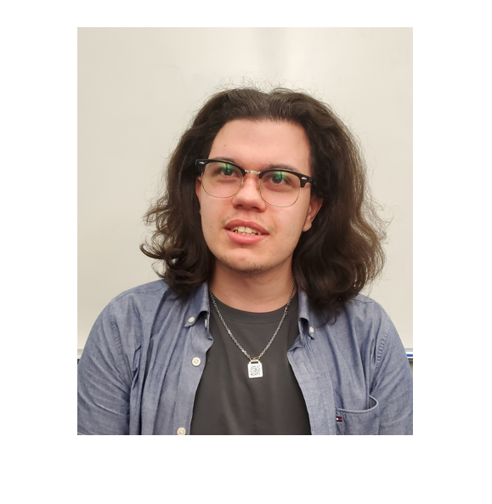

Segmented Inversion Image

(Question 4d)

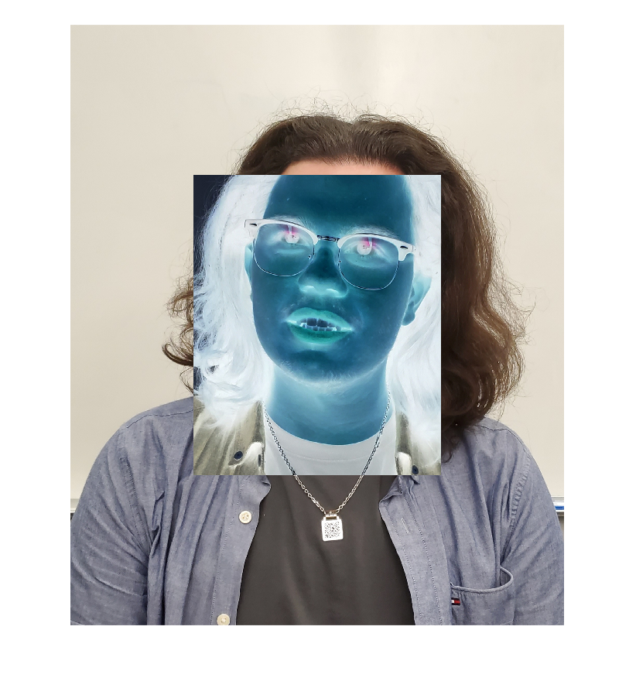

Quality Differences

(Question 4e)

(Quality of 5 is on the left, Quality of 90 is on the right)

The lower the quality, the higher the contrast.

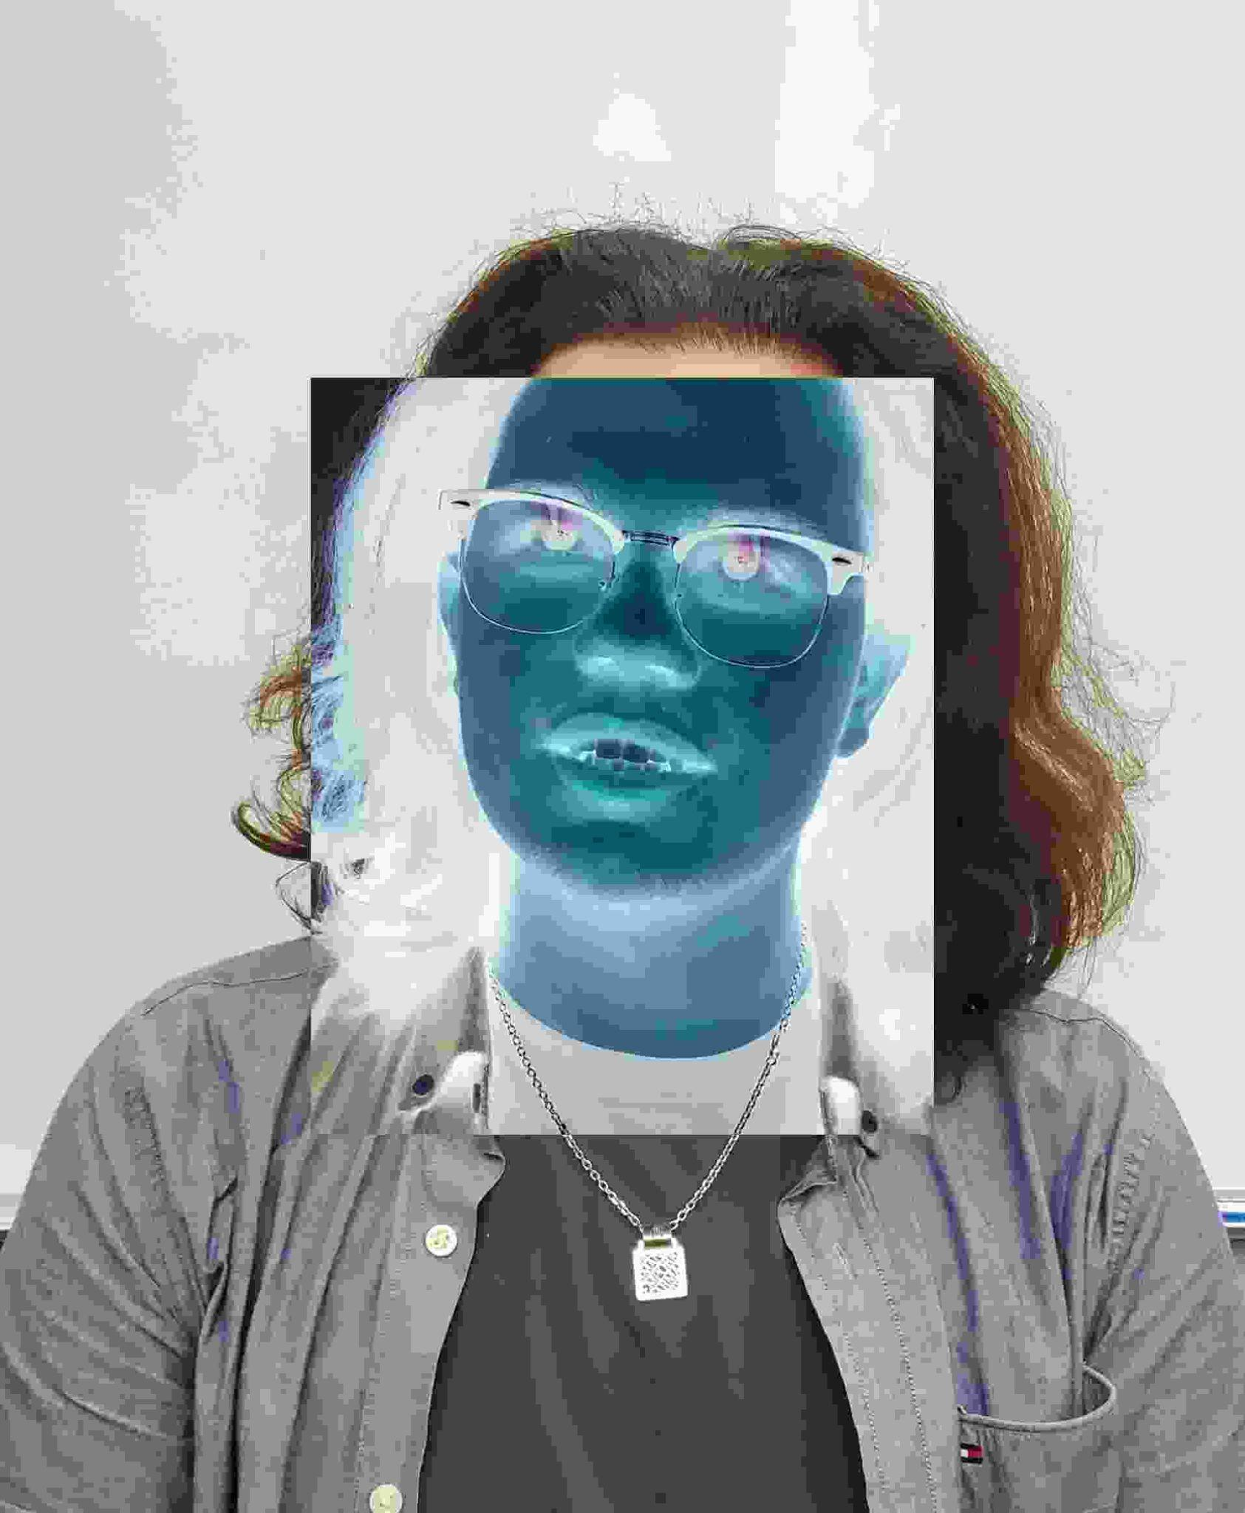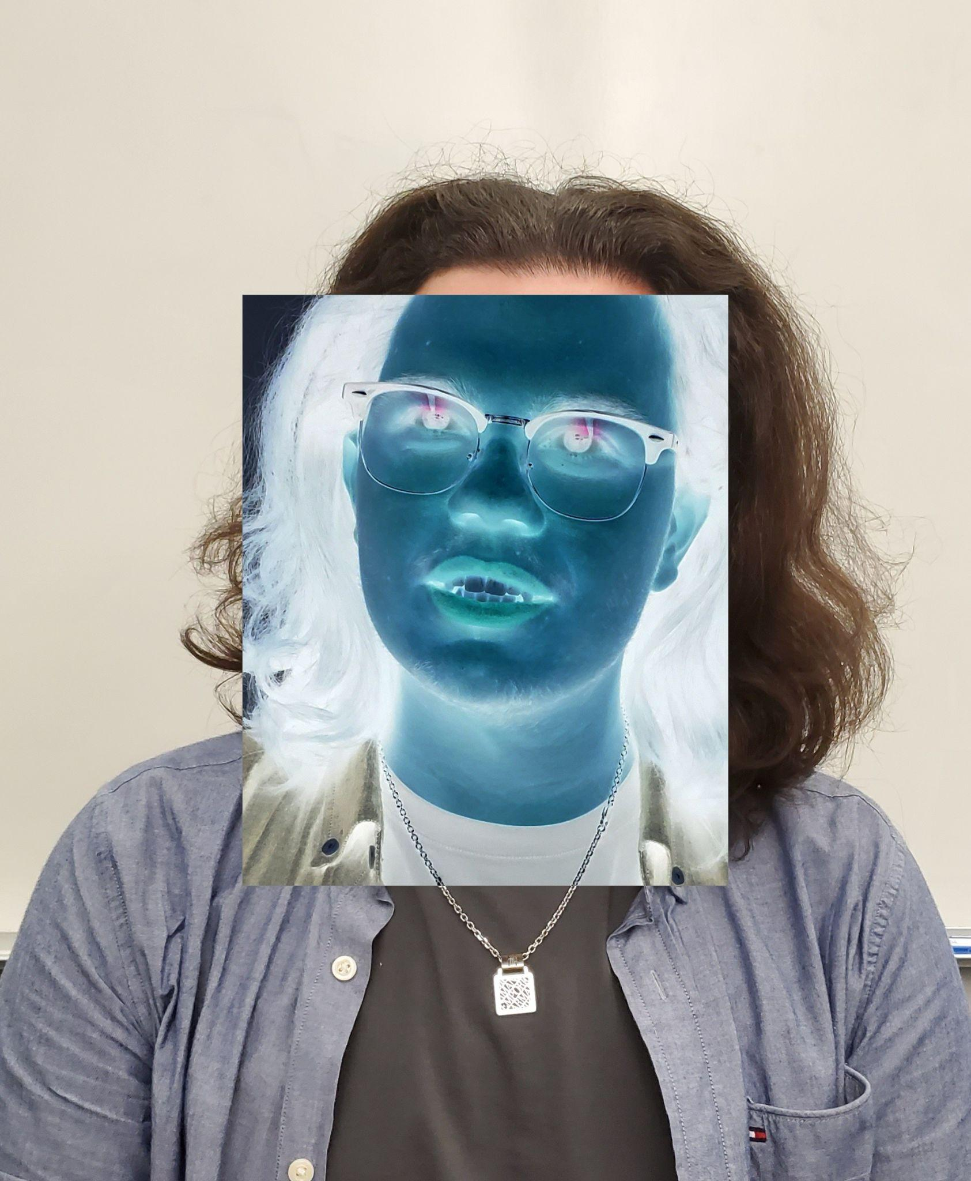

Red, Green, and Blue Inversions Images

(Question 4G)

(In order, Red inverted, Green inverted, Blue inverted)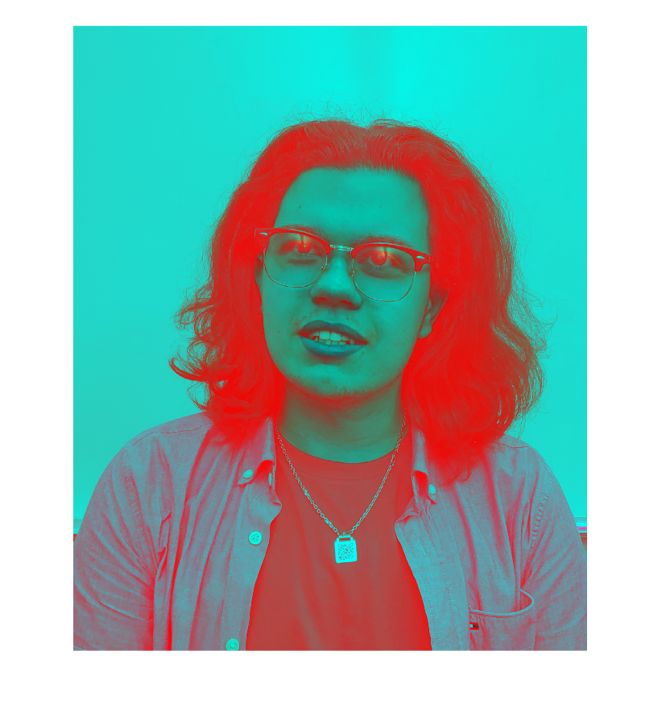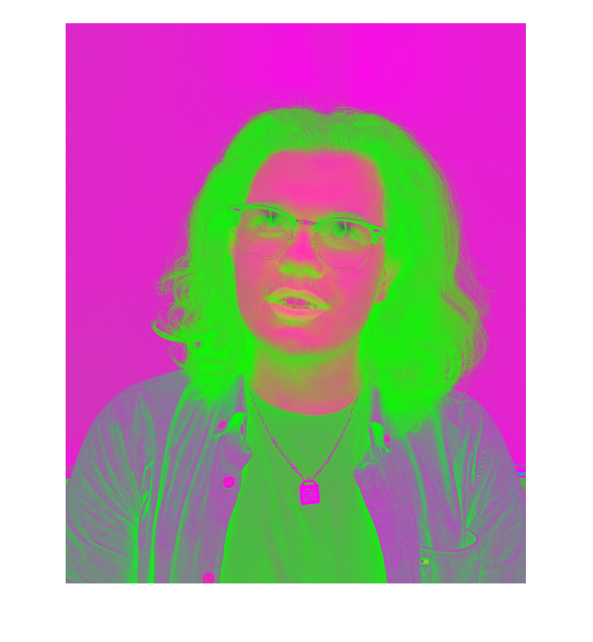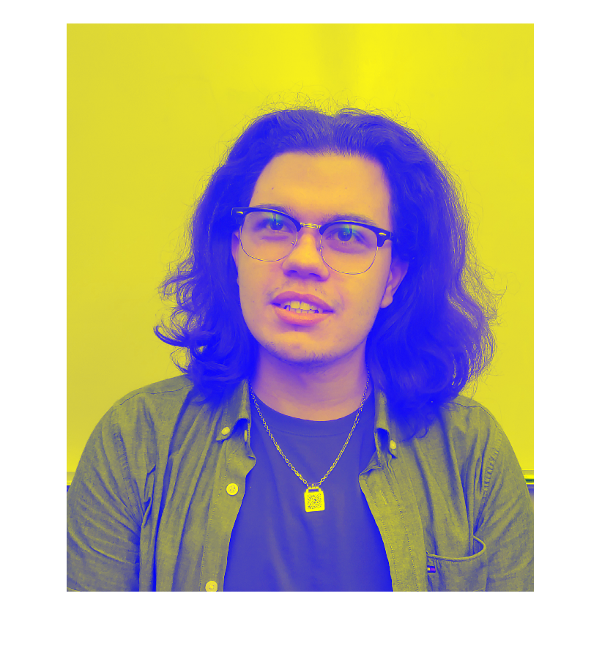

Image Differences

(Question 4H)

Left is (my_image - partner_image)   
Right is (partner_image - my_image)

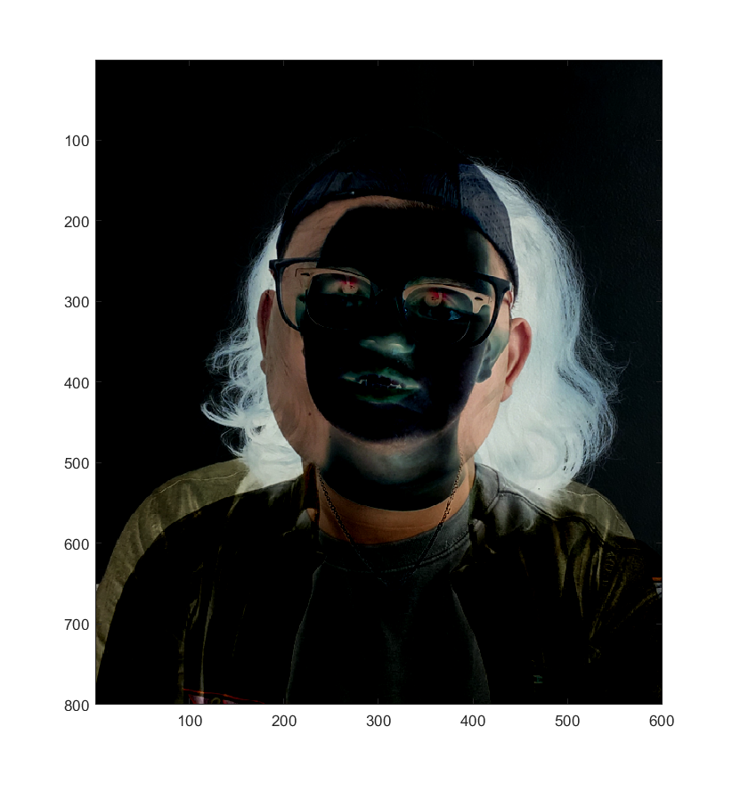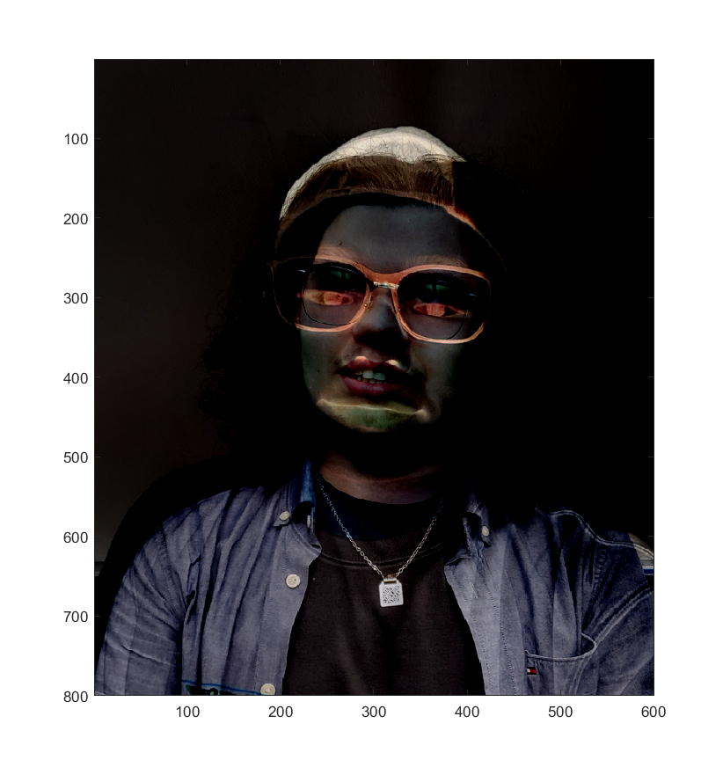

HSV Images

(Question 4I)

In order (Red channel, Green channel, Blue channel)

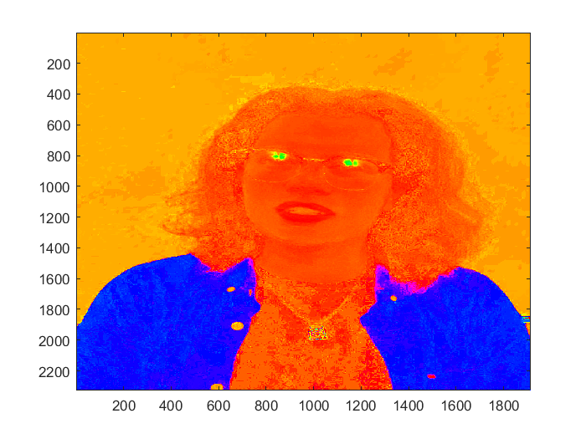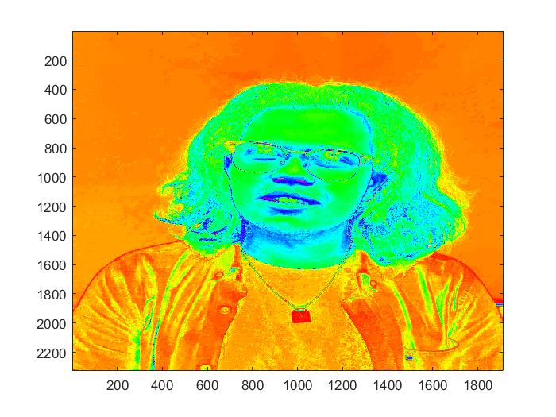

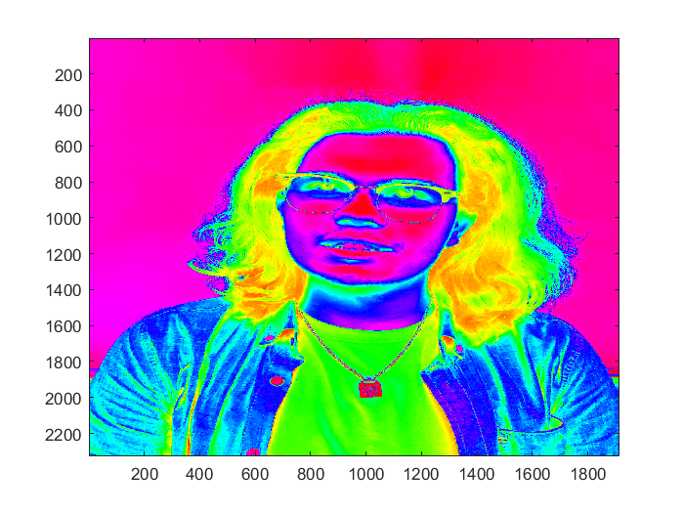

Conclusion

In short, I have not used Matlab since my first year, so there was a re-learning curve; though most relied heavily on learning what most of the methods do in Matlab’s Image Processing Toolbox plugin. I decided to have a separate function handle each individual question.

Reading the image was fairly straightforward, it just required us to read an image via the *imread()* function, then show it using *imshow()*. From this basic understanding of how to display an image, I was able to turn it into a grayscale image using *rgb2gray()*. Next followed learning how to swap color ranges and shrinking the image using *imresize()*. A note about this particular method, *NaN* can be used as an argument in an image matrix to prevent the “squishing” of an image while keeping the other argument as is. For example, using [480, *NaN*] forces an image to be at max 480 rows high). With this shrunken image the color channels can be swapped by simply changing the bolded numbers around in *image( : , : ,* ***[1, 2, 3]*** *)*. Those numbers show the channel numbers in order of *[red, green, blue]*, so swapping the red and green around is as simple as *image( : , : ,* ***[2, 1, 3]*** *).*

Moving onto the next major aspect, understanding how to select only a certain section of an image. After some time of head-scratching, the solution was far simpler than I imagined; it was simply to iterate over a matrix and just determine appropriate bounds to complement an individual pixel of an image. This resulted in a picture that gave me a decent laugh the first time I saw it (Images under Question 4D). With this newly attained image, I learned the impacts of Quality when using *imwrite()*. It seems that the lower the quality value, the higher the contrast in the images. For fun, I decided to see the differences between using qualities of 10 - 100; and the results were not what I expected. The contrast seemed to plateau at any value over 10, so an image with a quality of 20 looks identical to an image with a quality of 100. I expected the contrast to be extremely low; an interesting learning experience.

The next question was a decently large “head-scratcher”. Where every idea I had didn’t work until I overheard someone talk about splitting a bill 3 ways; which led me to think of separating the red, green, and blue channels, manipulating them, then combining them back again. Like in a previous question, this utilized knowing how to manipulate color channels. The channel separation followed *image(: , : ,1)* to select only the red channel. Then using *imcomplement(image)* to get the inverse of just that one channel, then using *cat()* to concatenate the channels back together.

For the last portion of this, I got my friend’s image and created some (fun) images to look at; the main contrast between our facial features and hair led to more images that got a laugh out of me. I took the files in, turned them both into doubles, then resized them, which led to some “squishing”. I also decided to see both differences created by our images; one of which made my hair entirely white; I believe this was due to my image being inverted. Also, my friend’s image was still the same. I think this happens when an image with more dark pixels is subtracted from an image with more light pixels (light - dark). Usually, the lighter the color, the greater the hex code, and the darker the color, the smaller the hex code. This difference just leads to a light color; hence my hair turning white in the image. Lastly, turning the final images into a HSV format using different hues of 1, 2, or 3 (red, green, blue) respectively led to more interesting images, one of which made me look like a carrot. This HSV format is created by taking the individual RGB values and turning them into a Hue Saturation Value combination.